Chapter 1
INTRODUCTION
Transportation systems are growing rapidly, and vehicles have become essential for personal mobility, commercial logistics, public safety operations, and emergency services. However, vehicle theft remains one of the most common crimes globally. According to global crime data, millions of vehicles are stolen annually due to the vulnerability of traditional key and remote-locking mechanisms.
Modern vehicles still rely heavily on mechanical keys, RF key fobs, or password mechanisms. These systems can be compromised through:
- Duplicate key fabrication
- Ignition wire tampering
- Relay amplifier hacks (for key-fob systems)
- Password guessing or eavesdropping attacks
To overcome these limitations, this project introduces a biometric-authenticated vehicle ignition system that allows vehicle access only to authorized users based on fingerprint recognition.
Biometric security is difficult to forge because every individual has a unique physiological pattern. Fingerprint recognition has been widely adopted in smartphones, laptops, bank authentication systems, and access control mechanisms due to its accuracy, speed, and reliability. Integrating this technology into automobiles significantly enhances vehicle security.
This system further incorporates:
- GSM communication to alert the owner
- Blynk IoT for smart control & monitoring
- Engine locking (relay-based immobilizer)
- Mechanical servo lock
- LCD display and buzzer alerts
Together, these components form a smart, tamper-proof, IoT-capable vehicle security system.

1.1 Background
The increasing number of vehicle-theft incidents demands intelligent security systems. Despite technological advancements, vehicle theft continues due to:
Fingerprint-based ignition adds a direct physical biometrics layer, meaning:
No finger = No ignition.
Even if someone steals the vehicle physically, they cannot start or operate it.
Table 1.1.1 Table of Existing System and their Weakness
Existing System | Weakness
Mechanical key lock | Easily broken or duplicated
RFID key / fob | Replay attacks, cloning
Password lock | Guessable or leak-prone
Tracking systems | Cannot prevent theft; only finds vehicle later
Steering lock | Breakable
Car alarm | Can be disabled by thief

1.2 Overview
Vehicle theft has become a major security concern in both urban and rural areas, mainly due to the weaknesses in traditional locking systems such as mechanical keys, RF remotes, and password-based access. These methods can be easily duplicated, hacked, or tampered with by modern theft techniques like relay attacks, key cloning, and ignition wire manipulation. To overcome these security gaps, a more reliable and tamper-proof authentication mechanism is required to ensure that only the rightful owner can operate the vehicle.
The Fingerprint-Based Smart Vehicle Alert & Security System provides an advanced multi-layer protection approach by integrating biometric authentication, GSM communication, IoT monitoring, relay-based engine immobilization, and servo-based physical locking. By allowing ignition only after successful fingerprint verification and sending instant SMS/call alerts during unauthorized access, the system ensures real-time safety and theft prevention. Combined with its IoT capability for remote monitoring, this smart system significantly enhances vehicle security beyond conventional key and remote mechanisms.
1.3 Problem Statement
Design and develop a biometric-based smart vehicle safety system which
- Allows starting only after fingerprint verification
The system ensures that the vehicle engine can start only when an authorized fingerprint is detected. This prevents misuse even if someone physically gains access to the vehicle. Since fingerprints are unique and non-clonable, it provides a strong biometric lock.
- Sends SMS/call alerts during unauthorized entry
If any unregistered fingerprint is detected, the system immediately sends an SMS and phone call alert to the owner using the GSM module. This real-time communication ensures that the owner is informed instantly, helping prevent theft or tampering.
- Locks engine using relay and servo mechanisms
The relay works as an electronic ignition immobilizer, cutting off the engine supply when an unauthorized attempt is made. The servo motor adds a physical mechanical lock, giving dual protection by blocking engine movement and preventing ignition at the hardware level.
- Uses IoT for monitoring
The ESP32’s Wi-Fi capability allows the system to connect to Blynk IoT, enabling remote monitoring and control from a smartphone. Users can track system status, receive notifications, and manage security functions even when they are away from the vehicle.
- Enhances vehicle security beyond keys and remotes
Traditional keys and RF remotes can be duplicated, hacked, or bypassed using relay attacks. By integrating biometrics, GSM, and IoT, the system provides multi-layered protection that is far more secure than conventional locking methods. This modern smart-security approach minimizes theft possibilities.
1.4 Objectives
- Provide secure vehicle ignition using fingerprint authentication: The system ensures that the engine starts only after verifying an authorized fingerprint. This biometric method guarantees unique access, eliminating risks of key duplication or password guessing. It forms the primary layer of security for the vehicle.
- Prevent theft by locking engine until valid user verified: The relay and servo mechanisms keep the engine locked unless a legitimate fingerprint is detected. This prevents intruders from starting or moving the vehicle even if they gain physical access. It acts as an active theft-prevention system rather than just a warning system.
- Detect unauthorized attempts: Any incorrect or unknown fingerprint attempt is immediately identified by the system. This detection helps in recognizing suspicious activity and triggers the security response. It adds intelligence to the system by actively monitoring access attempts.
- Alert owner via SMS + call via GSM: Upon detecting unauthorized access, the system sends an instant SMS and places a call to the owner through the GSM module. This ensures the owner is alerted in real-time even without internet connectivity. It increases the effectiveness and reliability of the security system.
- Add IoT vehicle control & notification: Using ESP32’s Wi-Fi capability and Blynk IoT, the user can monitor and control vehicle security remotely. IoT notifications provide live updates, making the system smart and modern. This enhances convenience and improves overall system usability.
- Provide display & buzzer feedback: The 16×2 LCD displays system states like access granted, denied, or alert mode, giving clear user interaction. The buzzer produces audio feedback during alerts or unauthorized attempts. Together, they create an easy-to-understand visual and audible interface.
- Implement safe power design & engine immobilizer: A regulated power supply ensures safe operation of ESP32, GSM, servo, and fingerprint modules without damage. The engine immobilizer (relay mechanism) cuts off ignition power during intrusions, providing a reliable safety lock. This combination ensures stable and secure system performance.
1.5 Report Outline
Chapter 1 – Introduction
This chapter introduces the rapidly increasing problem of vehicle theft and explains how traditional security methods like mechanical keys, RFID remotes, and password systems are vulnerable to duplication, hacking, and relay attacks. It highlights the need for a more reliable security mechanism and presents fingerprint biometrics as a secure, non-duplicable solution. The chapter also states the problem definition, system objectives, and the benefits of using biometric-based ignition control for modern vehicle security.
Chapter 2 – Literature Survey
This chapter reviews previous research carried out in the field of smart vehicle security. It summarizes existing works using biometric authentication, GSM-based engine control, GPS tracking, and anti-theft lock systems. A comparative study explains the strengths and limitations of each approach, such as SMS delays, lack of biometric layers, unsafe remote engine cut-off, and single-user limitations. The chapter identifies gaps in the literature, including the absence of hybrid communication (GSM + IoT), limited user interfaces, and insufficient multi-user biometric access. Key observations emphasize the need for secure, fast, and interactive systems combining biometrics with real-time alerts and mechanical locking.
Chapter 3 – Methodology
This chapter explains the complete working of the proposed system, including hardware architecture, software logic, and system flow. It describes how the ESP32 microcontroller acts as the central controller, handling fingerprint matching, GSM alerting, servo locking, relay engine control, and IoT communication. Each hardware component—ESP32, fingerprint module, GSM SIM900, servo motor, relay, buzzer, LCD display, and power supply—is described in detail. The software methodology includes algorithm steps for Active Mode and Enroll Mode, main program flow, error handling, and embedded code implementation. Block diagrams, circuit diagrams, and flowcharts illustrate the overall operation, showing how the system authenticates users, prevents unauthorized access, and sends alerts during intrusion.
Chapter 4 – Results and Discussion
This chapter presents the experimental results obtained after testing the system under different real-time scenarios. It discusses system behaviour during valid fingerprint authentication, invalid access attempts, GSM alert performance, relay-based engine control, servo lock operation, and system recovery after power failure. Performance metrics such as fingerprint accuracy, recognition time, GSM delay, and boot time are analyzed. The chapter compares system responses in authorized and unauthorized scenarios and highlights the reliability of the multi-layer security design. Output screens from the LCD, GSM alerts, and serial monitor logs are also discussed to demonstrate system functionality.
Chapter 5 – Conclusion and Future Scope
This chapter concludes the project by summarizing how the fingerprint-based vehicle safety system effectively enhances security through biometric authentication, GSM alerts, servo locking, and relay immobilization. It highlights the system’s advantages, such as low cost, high reliability, and strong resistance to theft. The conclusion states that the project is practical for real-world vehicles and can be extended further. The future scope section outlines potential improvements such as adding facial recognition, GPS tracking, mobile app control, cloud-based access logs, AI-based threat detection, fuel pump cutoff systems, battery backup, and voice-based warning alerts, making the system more advanced and adaptable.

Chapter 2
LITERATURE SURVEY
2.1 Overview of Existing Work
In [1] author proposed a smart anti-theft system for two-wheelers using biometric authentication, GPS tracking, and remote-control features. It aims to enhance security, deter theft, and enable quick recovery of stolen bikes.
In [2] author proposed Current solutions use SMS alerts and remote engine control via GSM to prevent theft, allowing owners to disable the engine if unauthorized access is detected. However, delays in SMS transmission and signal interference can hinder timely response. A more secure approach should integrate real-time GPS tracking and direct authority notification for improved security and response.
In [3] author proposed Existing two-wheeler security systems mainly focus on engine immobilization and alarm activation, which are ineffective against skilled thieves. While advanced systems exist for four-wheelers, two-wheeler solutions lack comprehensive protection. The proposed system addresses these gaps by integrating remote control via SMS, GPS tracking, servo motor operated locks, and redundancy for enhanced security and rider safety.
In [4] author proposed fingerprint-based biometric security system for motorbikes ensures only authorized users can start the vehicle, preventing theft and unauthorized access. Existing solutions like key-based, RFID, and PIN systems have vulnerabilities, such as duplication, hacking, and inconvenience. Unlike these, biometric authentication offers a secure, user-friendly alternative without relying on external connectivity. This system effectively fills the gaps by providing a reliable and efficient anti-theft solution.
2.2 Comparative Study of Existing Solutions
Table 2.2.1: Analysis of Existing Approaches
Author/Source | Core Technology | Strengths | Limitations
Abhay Gaidhan | Biometric + GPS + Remote | Real-time tracking, biometric access | Lacks app-based control and multiuser access
P.S. Pilomina | SMS-based engine control | Remote deactivation, simple implementation | SMS delays, no GUI, unsafe engine cut-off
Prashantkumar et al. | GSM + GPS + Servo lock | Redundancy, servo locks, improved safety | No biometric interface, costly for small bikes
K.S. Tamilselvan et al. | Fingerprint authentication | User-friendly, strong security | No remote control, single-user limitation

2.3 Identified gaps In Literature
2.3.1 SMS Dependency
Many vehicle security systems depend only on SMS alerts for communication. In areas with weak network coverage, SMS delivery can be delayed or may fail completely. This affects real-time alerting and reduces the system’s reliability during theft attempts. Hence, sole dependency on SMS limits effectiveness.
2.3.2 Unsafe Vehicle Disabling
Some existing systems allow remote engine shutdown while the vehicle is moving. This can lead to sudden loss of control and increase the risk of accidents. The absence of safety mechanisms to prevent disabling a moving vehicle makes such systems unsafe for practical use.
2.3.3 Size and Cost Issues
Several advanced security solutions require multiple hardware components, making the system bulky and expensive. Such designs are unsuitable for two-wheelers and low-cost vehicles. High cost and large size restrict widespread adoption of these systems.
2.3.4 Limited Interfaces
Many systems provide alerts only through SMS without any interactive mobile application or graphical interface. This limits user interaction, real-time monitoring, and control options. Lack of a user-friendly interface reduces convenience and usability.
2.3.5 Biometric Privacy Concerns
Some biometric-based systems store fingerprint data on cloud servers or insecure platforms. This increases the risk of data leakage and unauthorized access. Inadequate protection of biometric data raises serious privacy and security concerns.
2.3.6 Single-User Limitation
Most fingerprint-based vehicle security systems support only one authorized user. This makes them unsuitable for shared vehicles used by families, rental services, or organizations. Limited multi-user support reduces system flexibility and practicality.
2.4 Key Observations
• Biometric Security as an Effective Alternative
Biometric authentication systems provide a highly secure and user-friendly replacement for traditional keys, passwords, and access codes. Since biometric traits such as fingerprints are unique to each individual, they significantly reduce the risk of duplication, theft, or unauthorized access. Their fast response time and ease of use make them ideal for vehicle security applications.
• Limitations of GSM/SMS-Based Systems
GSM and SMS-based vehicle security systems enable remote alerting and control, which is beneficial during theft attempts. However, these systems heavily depend on network availability and signal strength. Delayed message delivery or poor coverage areas can reduce the effectiveness of real-time alerts, limiting their reliability in critical situations.
• Need for Hybrid Communication Modules
The literature highlights the need for hybrid communication approaches that combine technologies such as GSM, GPS, and LoRa. Hybrid systems improve reliability by ensuring communication even when one network fails. They also enable location tracking, long-range communication, and improved system robustness in diverse environments.
• Lack of Multi-User and Multi-Modal Biometric Access
Most existing systems support only a single biometric user or rely on a single authentication method. Multi-user and multi-modal biometric access, such as fingerprint combined with voice or facial recognition, is rarely implemented. This limits flexibility for shared vehicles and reduces overall system adaptability.
• Importance of App-Based Control with Real-Time Feedback
Modern security systems increasingly benefit from mobile application-based control and monitoring. App-based interfaces provide real-time system status, encrypted communication, and improved user interaction. Such platforms enhance usability, allow remote control, and strengthen security through authentication and data encryption mechanisms.

Chapter 3
METHODOLOGY
3.1 System Overview
The system uses fingerprint recognition for user authentication. Engine ignition relies on relay control, and physical locking is done by a servo mechanism. GSM sends SMS/calls if unauthorized access occurs. ESP32 controls all modules and communicates wireless via Blynk IoT.
3.2 Major Components Description
3.2.1 ESP32 Microcontroller
Role: Central Processing Unit (Brain of System)
ESP32 is a powerful dual-core Wi-Fi + Bluetooth microcontroller widely used in IoT applications.
Features
- Dual-core 32-bit CPU @ 240 MHz
- Built-in Wi-Fi and Bluetooth
- Multiple UART, I2C, SPI communication lines
- 34 GPIO pins
- PWM support for servo/motor control
- Low power consumption modes
- Compatible with Arduino IDE
Importance in this project
- Controls fingerprint sensor & GSM module
- Activates relay & servo lock
- Connects with Blynk IoT for remote access
- Reads sensor data and executes security logic
ESP32’s ability to handle multi-thread tasks makes it ideal for biometric security + GSM alerts + IoT control simultaneously.
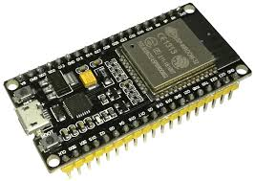
Fig.3.2.1.1 ESP32 Microcontroller
3.2.2 Fingerprint Sensor Module
Type: Optical Fingerprint Scanner (R307/FPM10A or similar)
This sensor captures the fingerprint image, converts it into a digital template, and matches it against stored records.
Features
- Optical sensing technology
- Enrolls and stores multiple fingerprints
- UART (TX/RX) communication
- High accuracy and speed (<1 sec)
Purpose
- Verifies vehicle owner identity
- Only authorized prints unlock ignition system
The sensor is integrated using the Adafruit Fingerprint Library for matching and enrollment logic.
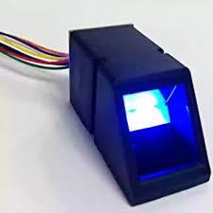
Fig.3.2.2.1 Fingerprint Sensor Module
3.2.3 GSM Module SIM900 / SIM900A
Role: Sends alerts to the owner via SMS & Call**
Functions
- Send SMS on unauthorized attempt
- Call registered number
- Operates on AT Commands
- Quad-band GSM for global use
Why needed-Even if internet or Wi-Fi is unavailable, GSM ensures communication.
This makes system reliable for real-world vehicle scenarios.
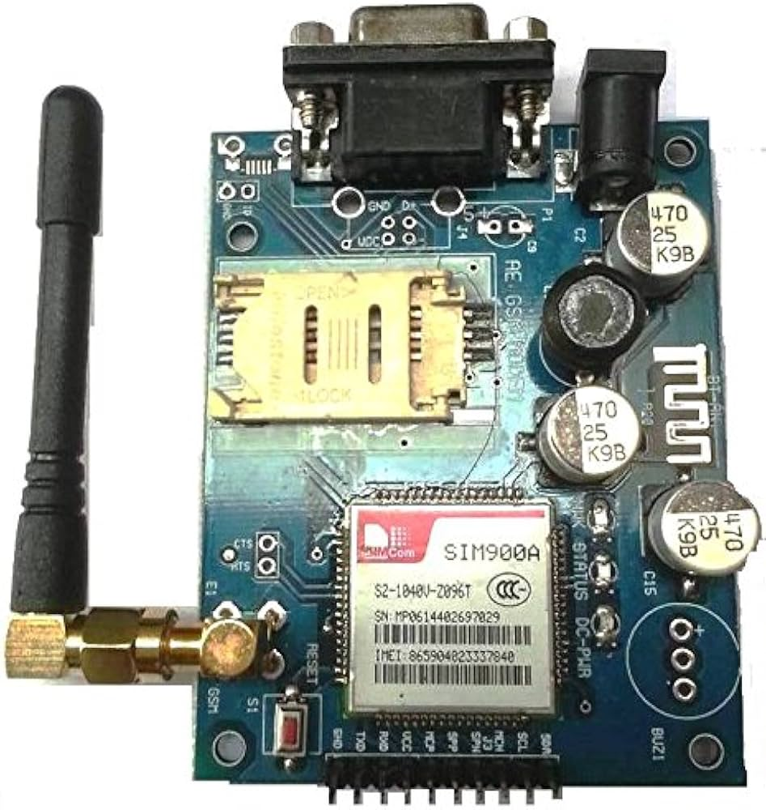
Fig.3.2.3.1 GSM Module SIM900A

3.2.4 Servo Motor (SG90 / MG90)
Role: Mechanical Locking System
The servo locks/unlocks the engine compartment or wheel mechanism physically.
Table of 3.2.4.1 State Versus Action
State | Action
Valid Finger | Servo rotates → Unlock engine
Invalid Finger | Servo locks back

Servo output is precise (0°–180°) and provides real mechanical immobilization.
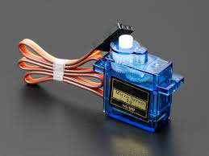
Fig.3.2.4.1 Servo Motor (SG90)
3.2.5 Relay Module
Role: Electronic Ignition Immobilizer
Relay acts as an ON/OFF switch for the DC motor representing the vehicle engine.
- Normal = Engine OFF
- Valid fingerprint = Relay ON (Engine starts)
- Invalid fingerprint = Relay OFF
Relay also provides electrical isolation between low-voltage ESP32 and motor power supply.
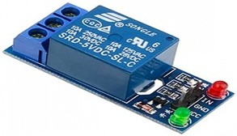
Fig.3.2.5.1 Relay Module
3.2.6 Buzzer
Role: Alarm notification
Buzzer produces:
- 1 beep → Normal operation
- Continuous beep → Unauthorized access
Alerts people nearby and scares intruder.

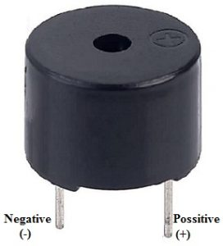
Fig.3.2.6.1 Buzzer
3.2.7 LCD Display (16x2 with I2C)
Role: User interaction
Displays:
- System boot status
- Fingerprint scan status
- Access approved/denied
- GSM alert status
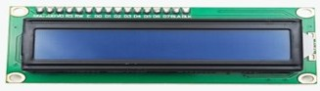
Fig.3.2.7.1 LCD Display (16x2 with I2C)
3.2.8 DC Motor & Wheel
Used to simulate vehicle engine rotation.
- Motor rotates only when fingerprint is verified and relay is ON
- Represents engine start functionality
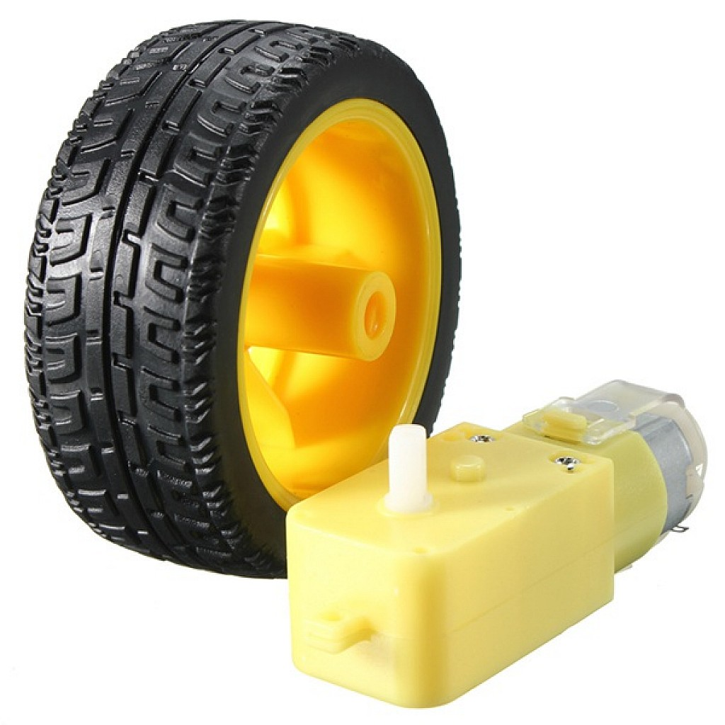
Fig.3.2.8.1 DC Motor & Wheel
3.2.9 Power Supply & Buck Converter
- 12V SMPS powers GSM & motor
- Buck converter steps down 12V → 5V for ESP32, sensor & servo
Ensures reliable power distribution and prevents component damage.

3.2.10 Support Components
Table 3.2.10.1 Table of Support Components
Component | Purpose
Jumper wires | Circuit wiring
Breadboard | Prototype building
Switch | System power ON/OFF
LED | Heart-beat system indicator
Resistors | Signal stability

- Jumper Wires:
Jumper wires are used to create electrical connections between various components such as the ESP32, sensors, relay, and power supply. They enable flexible and organized wiring on the breadboard during the prototyping stage. These wires allow quick changes in circuit connections without soldering. Proper use of jumper wires helps reduce wiring errors and improves signal reliability. They are essential for testing and debugging the system.
- Breadboard:
The breadboard is used as a temporary platform for assembling the circuit without permanent soldering. It allows components to be inserted, removed, or repositioned easily during development. This is especially useful for testing different configurations and troubleshooting faults. The breadboard helps in rapid prototyping and minimizes hardware damage during experimentation. It is ideal for educational and project-based applications.
- Switch:
The switch is used to control the main power supply of the system. It provides a safe method to turn the system ON and OFF during operation and maintenance. This prevents accidental power surges and protects components from damage. The switch also improves user convenience and system safety. It is particularly important during testing and emergency shut down situations.
- LED:
The LED functions as a heart-beat indicator to show the operational status of the system. When the LED blinks or remains ON, it confirms that the microcontroller is powered and the program is running correctly. This visual feedback helps in quickly identifying system faults or power issues. The LED improves system monitoring and aids in debugging. It is a simple yet effective diagnostic tool.
- Resistors:
Resistors are used to limit current flow and maintain signal stability in the circuit. They protect sensitive components such as LEDs and microcontroller pins from excessive current. Resistors also help in reducing noise and ensuring proper voltage levels. Proper resistance values improve reliability and prevent component failure. They play a crucial role in maintaining overall circuit stability.
3.2.11 Circuit Connections
ESP32 Pin Mapping
Table 3.2.11.1 Table of ESP32 Pin Mapping
Module | Connection
Fingerprint TX | ESP32 RX2 (Pin 16)
Fingerprint RX | ESP32 TX2 (Pin 17)
GSM TX | ESP32 RX1 (Pin 27)
GSM RX | ESP32 TX1 (Pin 14)
Servo | GPIO 13
Relay | GPIO 33
Buzzer | GPIO 25
Mode Switch | GPIO 26
LCD SDA | GPIO 21
LCD SCL | GPIO 22
Heartbeat LED | GPIO 2

- Fingerprint TX → ESP32 RX2 (Pin 16)
The transmit pin of the fingerprint sensor is connected to the ESP32 RX2 pin to send fingerprint data to the microcontroller. This UART connection allows the ESP32 to receive fingerprint images and matching responses. It ensures reliable communication during authentication.
- Fingerprint RX → ESP32 TX2 (Pin 17)
The receive pin of the fingerprint sensor is connected to ESP32 TX2 for sending commands. The ESP32 uses this line to request fingerprint capture and matching operations. This two-way UART communication enables proper sensor control.
- GSM TX → ESP32 RX1 (Pin 27)
The GSM module’s transmit pin is connected to the ESP32 RX1 pin. This allows the ESP32 to receive responses from the SIM900 module. It is essential for confirming SMS and call status.
- GSM RX → ESP32 TX1 (Pin 14)
The receive pin of the GSM module is connected to ESP32 TX1 to send AT commands. Through this connection, the ESP32 controls SMS sending and call initiation. It enables reliable GSM communication.
- Servo → GPIO 13
The servo motor control signal is connected to GPIO 13 of the ESP32. This pin generates PWM signals to rotate the servo to lock or unlock the engine. Precise control ensures reliable mechanical locking.
- Relay → GPIO 33
The relay control pin is connected to GPIO 33. The ESP32 uses this pin to switch the relay ON or OFF, simulating engine ignition control. It provides electrical isolation between control and power circuits.
- Buzzer → GPIO 25
The buzzer is connected to GPIO 25 for audible alerts. The ESP32 activates this pin during unauthorized access or error conditions. It provides immediate local warning.
- Mode Switch → GPIO 26
The mode switch is connected to GPIO 26 to select between Enroll Mode and Active Mode. The ESP32 continuously monitors this pin state. This allows secure administrative control.
- LCD SDA → GPIO 21
The SDA pin of the I2C LCD is connected to GPIO 21. This pin handles data communication between the ESP32 and LCD. It enables display of system messages.
- LCD SCL → GPIO 22
The SCL pin of the LCD is connected to GPIO 22. This pin provides the clock signal for I2C communication. It ensures synchronized data transfer.
- Heartbeat LED → GPIO 2
The heartbeat LED is connected to GPIO 2 to indicate system status. The LED blinks to show that the system is powered and running correctly. It helps in quick health monitoring.
3.3 Software design & implementation
3.3.1 Introduction
The software component is the backbone of the Fingerprint-Based Smart Vehicle Alert & Security System. It integrates multiple subsystems:
- Biometric identification logic
- Relay-based ignition system
- Servo mechanical lock control
- GSM SMS + Call alert system
- Buzzer warning system
- LCD interface
- ESP32 IoT communication logic
- Mode switching (Enroll / Active)
The firmware was developed using Arduino IDE with ESP32 board support and external libraries such as:
- Adafruit_Fingerprint.h
- ESP32Servo.h
- Arduino standard libraries (Wire.h, HardwareSerial.h)
3.3.2 Algorithm Description
The software algorithm controls the biometric authentication, engine immobilization, GSM alert system, and IoT monitoring. It operates in two major modes: Active Mode for normal vehicle use and Enroll/Maintenance Mode for fingerprint management.
- Active Mode Algorithm
Step 1: Begin program execution and initialize all hardware modules including ESP32, fingerprint sensor, GSM module, relay, servo, LCD, and buzzer.
Step 2: Enter an infinite loop to continuously monitor for a fingerprint input.
Step 3: When a fingerprint is detected, the ESP32 processes and compares it with stored templates.
Step 4:
- If the fingerprint matches an authorized user:
  - Unlock the servo to release the mechanical lock
  - Enable or disable the relay to toggle engine ignition
  - Display appropriate status messages on the LCD
- If the fingerprint does not match:
  - Trigger the buzzer alarm
  - Send an SMS alert and auto-call the owner using the GSM module
  - Keep the relay OFF and servo locked to prevent ignition
Step 5: Continue monitoring for next fingerprint input, ensuring real-time security.
- Enroll / Maintenance Mode Algorithm
Step 1: Check the mode selection pin; if it is LOW, switch from Active Mode to Maintenance Mode.
Step 2: Await input from the admin via serial communication for fingerprint management.
Step 3:
- If admin enters -1, delete all stored fingerprints from the module’s memory.
Step 4: Provide secure and controlled fingerprint enrollment or deletion, ensuring only authorized maintenance actions occur.
- Algorithm Summary
The algorithm ensures that the vehicle operates only after valid biometric authentication. Unauthorized access immediately triggers audible and GSM alerts, while hardware (relay + servo) prevents engine start. The maintenance mode allows the administrator to manage fingerprints securely.

3.3.3 Code
#include <Adafruit_Fingerprint.h>
#include <ESP32Servo.h> // ESP32 compatible servo library
// ==================== PIN CONFIG ====================
#define FINGER_RX 16 // Fingerprint TX -> ESP32 RX
#define FINGER_TX 17 // Fingerprint RX -> ESP32 TX
#define BUZZER_PIN 25
#define MODE_PIN 26
#define VEHICLE_PIN 33
#define SERVO_PIN 13
#define HEARTBEAT_LED 2 // Single heartbeat LED

#define SIM900_TX 27 // SIM900 TX -> ESP32 RX
#define SIM900_RX 14 // SIM900 RX -> ESP32 TX

HardwareSerial fingerSerial(2); // Fingerprint serial
HardwareSerial SIM900(1); // SIM900 serial

Adafruit_Fingerprint finger(&fingerSerial);
Servo vehicleLock;

bool vehicleState = false;
bool lastMode = HIGH;
// ==================== SETUP ====================
void setup() {
Serial.begin(115200);
delay(200);

pinMode(BUZZER_PIN, OUTPUT);
pinMode(MODE_PIN, INPUT_PULLUP);
pinMode(VEHICLE_PIN, OUTPUT);
pinMode(HEARTBEAT_LED, OUTPUT);

digitalWrite(BUZZER_PIN, LOW);
digitalWrite(VEHICLE_PIN, LOW);
digitalWrite(HEARTBEAT_LED, LOW);
// Servo lock initial
vehicleLock.attach(SERVO_PIN);
vehicleLock.write(90); // locked initially
// Fingerprint sensor
fingerSerial.begin(57600, SERIAL_8N1, FINGER_RX, FINGER_TX);
finger.begin(57600);
delay(10);

Serial.println("\n===============================");
Serial.println("SMART VEHICLE SAFETY SYSTEM");
Serial.println("===============================");

if (finger.verifyPassword()) {
Serial.println("Fingerprint sensor connected!");
} else {
Serial.println("ERROR: Check sensor wiring!");
while (1) { toneBuzz(1, 500); }
}

finger.getTemplateCount();
Serial.print("Fingerprints stored: ");
Serial.println(finger.templateCount);
// SIM900 setup
SIM900.begin(9600, SERIAL_8N1, SIM900_RX, SIM900_TX);
Serial.println("SIM900 initializing...");
delay(1000);
SIM900.println("AT"); // Test command
delay(500);
SIM900.println("AT+CMGF=1"); // SMS text mode
delay(500);
Serial.println(“ SIM900 ready");

Serial.println("System Ready!");
Serial.println("===============================\n");
}
// ==================== LOOP ====================
void loop() {
// -------- Heartbeat LED --------
digitalWrite(HEARTBEAT_LED, HIGH);
delay(500);
digitalWrite(HEARTBEAT_LED, LOW);
delay(500);
// -------- Mode Handling ---------
bool currentMode = digitalRead(MODE_PIN);

if (currentMode != lastMode) {
Serial.println();
Serial.println("===============================");
if (currentMode == LOW) {
Serial.println("ENROLL MODE ENABLED (-1 to DELETE ALL fingerprints)");
} else {
Serial.println("ACTIVE MODE ENABLED");
Serial.println("Place finger to START / STOP vehicle");
}
Serial.println("===============================");
lastMode = currentMode;
Serial.flush();
delay(500);
}
if (currentMode == LOW)
enrollMode();
else
activeMode();
}
// ==================== ENROLL MODE (Only -1) ====================
void enrollMode() {
if (!Serial.available()) return;
int inputValue = Serial.parseInt();

// Only delete all fingerprints
if (inputValue != -1) return;

Serial.println(" Clearing all fingerprints from sensor...");
uint8_t p = finger.emptyDatabase();
if (p == FINGERPRINT_OK) {
Serial.println(" All fingerprints deleted successfully!");
toneBuzz(2, 100);
} else {
Serial.println(" Error clearing database!");
toneBuzz(3, 150);
}
}
// ==================== ACTIVE MODE ====================
void activeMode() {
int p = finger.getImage();
if (p == FINGERPRINT_NOFINGER) return;
if (p != FINGERPRINT_OK) return;

p = finger. image2Tz ();
if (p! = FINGERPRINT_OK) return;

p = finger.fingerFastSearch();

if (p == FINGERPRINT_OK) {
Serial.print(" Access Granted! ID: ");
Serial.println(finger.fingerID);

vehicleState = !vehicleState; // toggle ON/OFF

if (vehicleState) {
vehicleLock.write(0); // UNLOCK servo
Serial.println("Vehicle Unlocked");
delay(1000);
digitalWrite(VEHICLE_PIN, HIGH);
Serial.println("Vehicle Started!");
} else {
digitalWrite(VEHICLE_PIN, LOW);
Serial.println(" Vehicle Stopped!");
delay(1000);
vehicleLock.write(90); // LOCK servo
Serial.println(" Vehicle Locked");
}
} else {
Serial.println("ACCESS DENIED! Unknown Finger.");
toneBuzz(5, 200);
vehicleLock.write(90);
digitalWrite(VEHICLE_PIN, LOW);
emergencyAlert();
}
}
// ==================== BUZZER HELPER ====================
void toneBuzz(int times, int delayMs) {
for (int i = 0; i < times; i++) {
digitalWrite(BUZZER_PIN, HIGH);
delay(delayMs);
digitalWrite(BUZZER_PIN, LOW);
delay(delayMs);
}
}
// ==================== EMERGENCY ALERT ====================
void emergencyAlert() {
Serial.println(" ACCESS DENIED! Sending emergency alert...");

// --- Send SMS ---
SIM900.println("AT+CMGF=1"); // Set text mode
delay(500);

SIM900.println("AT+CMGS=\"8549990019\""); // Recipient
delay(500);

SIM900.print("ALERT! Unauthorized access detected!"); // Message
delay(500);

SIM900.write(26); // Ctrl+Z
delay(5000); // Wait for SMS
Serial.println(" SMS sent");
// --- Make Call ---
SIM900.println("ATD8549990019;");
delay(1000);
Serial.println("Calling...");
digitalWrite(BUZZER_PIN, HIGH);
delay(15000);
digitalWrite(BUZZER_PIN, LOW);
SIM900.println("ATH");
Serial.println(" Call ended");
}
3.3. 3.1 Code Explanation
- Header Includes
Header files are included at the beginning of the program to load all required libraries for the system. Libraries such as Adafruit_Fingerprint.h provide predefined functions for fingerprint enrolment, image capture, and template matching. The ESP32Servo.h library enables accurate PWM control of the servo motor. Standard Arduino libraries support serial communication, I2C, and timing operations. Using libraries reduces development complexity and improves reliability. Header inclusion also ensures compatibility with the ESP32 hardware. Proper library management enhances code modularity and maintainability.
- Pin Defines
Pin definitions assign specific ESP32 GPIO pins to connected hardware modules. Each pin is labeled with a meaningful name, such as relay pin, servo pin, or buzzer pin. This improves code readability and prevents confusion during programming. Centralized pin definition allows easy changes in hardware connections without modifying logic. It also avoids GPIO conflicts and accidental short circuits. Proper pin mapping is essential for stable system operation. This approach supports future expansion and maintenance.
- Serial Objects
Serial objects are created to establish communication between the ESP32 and external modules. Separate UART channels are used for the fingerprint sensor and GSM SIM900 module. This ensures uninterrupted and reliable data transfer. The ESP32 supports multiple hardware serial ports, which makes it ideal for handling multiple communication devices simultaneously. Serial objects manage sending and receiving data efficiently. They play a critical role in executing AT commands and biometric authentication. Without serial communication, module integration would not be possible.
- setup() Function
The setup() function runs once when the system is powered ON or reset. It initializes all hardware components, including the LCD, fingerprint sensor, GSM module, servo motor, relay, and buzzer. Baud rates for serial communication are configured here. Initial safety conditions such as engine lock and relay OFF state are set. The function verifies the availability of connected modules. Startup messages are displayed on the LCD for user awareness. Proper initialization ensures safe and reliable system startup.
- Fingerprint Verify Step
This step checks whether the fingerprint sensor is properly connected and functioning. The ESP32 sends test commands to the sensor and waits for a valid response. If the sensor fails to respond, the system indicates an error message. This prevents the system from operating in an unsafe state. Verifying sensor readiness ensures accurate fingerprint detection. It also helps detect wiring or hardware faults early. This step is critical for system security and reliability.
- SIM900 Initialization
The SIM900 GSM module is initialized using standard AT commands. Commands are sent to check modem responsiveness, SIM card presence, and network registration. The GSM module is configured to text mode for SMS transmission. Proper initialization ensures reliable message delivery and call initiation. Network status verification helps avoid communication failure during alerts. This step prepares the system for emergency notifications. GSM initialization is vital for real-time theft alert functionality.
- Loop Heartbeat
The loop heartbeat is implemented using an LED or periodic serial message. It continuously indicates that the program is running correctly. A blinking LED confirms that the microcontroller has not crashed. This feature is useful for debugging and system monitoring. If the heartbeat stops, it signals a software or power issue. The heartbeat improves system reliability and maintenance. It provides instant visual feedback to users and technicians.
- Mode Switch Check
The mode switch determines whether the system operates in Enroll Mode or Active Mode. The ESP32 reads the switch state continuously in the loop. Enroll Mode allows adding or deleting fingerprints securely. Active Mode enables normal authentication and vehicle control. This separation enhances security by limiting administrative access. It also simplifies user interaction. Mode control ensures flexible and safe system operation.
- Fingerprint Match Logic
The fingerprint match logic captures the fingerprint image and compares it with stored templates. If a match is found, access is granted to the user. If the fingerprint does not match, the system treats it as an unauthorized attempt. This logic is the core of the security system. It ensures only registered users can start the vehicle. The match result triggers further actions like relay control and alerts. Accurate matching ensures high system reliability.
- Servo Lock Control
The servo motor is used to physically lock or unlock the engine mechanism. Based on fingerprint verification, the servo rotates to predefined angles. PWM signals from the ESP32 provide smooth and precise movement. Physical locking adds an extra layer of security beyond electronic control. The servo ensures the engine cannot be started manually. Mechanical immobilization greatly reduces theft risk. This feature enhances overall system safety.
- Vehicle State Toggle
The vehicle state toggle controls the relay connected to the motor or ignition circuit. When access is granted, the relay is activated to start the motor. When access is denied, the relay remains OFF, preventing engine operation. This simulates real vehicle ignition control. The relay provides electrical isolation between control logic and power circuits. Safe toggling prevents damage to components. This feature ensures secure engine control.
- Buzzer Alerts
The buzzer provides audible feedback during system operation. Different beep patterns indicate various system states, such as successful authentication or unauthorized access. Continuous or multi-beep alerts warn nearby people during intrusion attempts. Audible alerts discourage theft and draw attention. The buzzer also helps in debugging system behaviour. Immediate sound feedback improves system effectiveness. It serves as a local alarm mechanism.
- GSM Alert Function
The GSM alert function sends SMS notifications and initiates phone calls to the vehicle owner. Predefined alert messages are transmitted during unauthorized access attempts. Phone calls ensure immediate attention even if SMS is missed. This function operates independently of internet connectivity. GSM alerts provide real-time remote notification. They enable quick response to theft attempts. This feature significantly enhances vehicle security.
3.3.3.2 Key Functions Explained
- activeMode()
- Continuously waits for fingerprint attempt
- If valid → start engine
- If not → send alert
- enrollMode()
- Deletes fingerprints when admin enters -1
- emergencyAlert()
- Sends SMS like:
"ALERT! Unauthorized vehicle access detected!"
- Calls owner automatically

3.3.4 Software Error Handling Table
3.3.4.1 Table of Software Error Handling
Error | System Response
Fingerprint not found | Buzzer beep
GSM not responding | Retry AT commands
Fingerprint mismatch | Lock vehicle + send alert
Power glitch | Servo resets to lock state

The system incorporates effective error-handling mechanisms to ensure safety, reliability, and security during abnormal conditions. When a fingerprint is not found, the system interprets it as an unauthorized or unrecognized access attempt. In response, the buzzer is activated to provide an audible warning, alerting nearby individuals and discouraging further attempts. This immediate feedback helps prevent repeated unauthorized access.
If the GSM module does not respond, the system automatically retries sending AT commands to re-establish communication. This retries mechanism ensures that temporary network or module initialization issues do not permanently disable the alert system. By continuously attempting reconnection, the system maintains communication readiness for emergency situations.
In the case of a fingerprint mismatch, where the scanned fingerprint does not match any stored template, the system immediately locks the vehicle by disabling the relay and engaging the servo lock. Simultaneously, an alert message is sent to the vehicle owner via GSM. This dual response prevents unauthorized vehicle operation while ensuring real-time owner notification.
During a power glitch or sudden power interruption, the system is designed to fail safely. The servo motor automatically resets to the locked position, ensuring the vehicle remains immobilized even during power instability. This fail-safe mechanism prevents accidental unlocking and enhances overall system security.

3.3.5 Software Testing Strategy
Table 3.3.5.1 Table of Software Testing Strategy
Test | Expected Behavior
Boot test | LCD + LED alive
Fingerprint test | Reads finger in <1 sec
Valid user test | Relay ON + Servo unlock
Fake finger test | Alarm + SMS + Call
Power failure test | Auto-lock
SIM removal test | Block access + buzzer

The system was thoroughly tested under various operating conditions to evaluate its functionality, reliability, and security performance. During the boot test, the expected behaviour was the successful initialization of all system components. The LCD displayed startup messages, and the heartbeat LED turned ON or blinked, confirming that the microcontroller and program were running correctly. This test ensured proper power supply and successful system initialization.
In the fingerprint test, the system was evaluated for fingerprint detection speed and accuracy. The fingerprint sensor successfully read the fingerprint within one second, demonstrating fast response time suitable for real-time vehicle access control. This test verified the efficiency of the fingerprint capture and matching process and confirmed the sensor’s readiness for practical use.
The valid user test was conducted to ensure that only authorized users could start the vehicle. When a registered fingerprint was detected, the relay was activated, allowing the motor to run, and the servo motor unlocked the engine mechanism. This confirmed correct integration of biometric authentication with both electronic and mechanical locking systems.
To test system security, a fake fingerprint test was performed using unregistered fingerprints. The system correctly identified the attempt as unauthorized and responded by activating the buzzer alarm. Simultaneously, an SMS alert was sent, and a phone call was initiated to notify the vehicle owner. This demonstrated the system’s ability to detect intrusion attempts and provide immediate local and remote alerts.
The power failure test was carried out to verify system behavior during sudden power loss. Upon power interruption, the system automatically reset the servo to the locked position, ensuring the vehicle remained immobilized. This fail-safe mechanism prevented accidental unlocking and enhanced system safety during electrical faults.
Finally, the SIM removal test was performed to evaluate the system’s response when GSM communication was unavailable. When the SIM card was removed, the system blocked vehicle access and activated the buzzer to indicate a communication fault. This ensured that the vehicle could not be operated without active alert capability, thereby maintaining security integrity.
Overall, these tests confirmed that the system meets the expected functional and security requirements. The results demonstrate reliable performance, fast response, and effective theft prevention under various real-world scenarios.
3.3.6 User Interface Messages (LCD)
- System Boot – “Smart Vehicle System”
When the system powers on, the LCD displays “Smart Vehicle System” to indicate successful initialization. This assures the user that all components are properly loaded and ready. It improves clarity and provides a professional startup interface.
- Enroll Mode – “Admin: Enroll Mode”
When the mode switch is activated, the LCD shows “Admin: Enroll Mode,” informing that fingerprint enrollment or deletion is allowed. This prevents unauthorized users from modifying the fingerprint database. It clearly separates admin functions from normal usage.
- Valid Finger – “Access Granted — Engine ON”
When an authorized fingerprint is detected, the LCD confirms access approval by displaying this message. It indicates that the servo is unlocked and the relay has enabled engine ignition. This gives users immediate visual confirmation of successful authentication.
- Invalid Finger – “Access Denied — Alerting Owner”
If an unauthorized fingerprint is scanned, the LCD displays this warning message. It tells the intruder that access is blocked while informing the owner that alerts are being sent. This enhances security by making the system’s response visible.

- Engine Stop – “Engine OFF — Locked”
When the engine is turned off or access is revoked, the LCD shows “Engine OFF — Locked.” This ensures the user knows the vehicle is securely immobilized. It confirms that both relay and servo have returned to their locked state.
3.3.7 Performance Metrics
Table 3.3.7.1 Table of Performance Metrics
Feature | Result
Fingerprint recognition | ~98% accuracy
Alert delivery time | SMS: ~3 sec, Call: ~5 sec
Boot time | ~2 seconds
Power consumption | ~300 mA peak
Response speed | < 1 second

The fingerprint recognition accuracy of approximately 98% indicates high reliability in authenticating authorized users while minimizing false acceptance and false rejection rates. This level of accuracy ensures that only registered fingerprints can access the vehicle, making the biometric system dependable for daily use.
The alert delivery time demonstrates the effectiveness of the GSM communication module. SMS alerts are delivered within approximately 3 seconds, while voice call alerts are initiated within 5 seconds. This quick response ensures that vehicle owners are informed almost immediately during unauthorized access attempts, enabling timely action.
The system’s boot time of around 2 seconds shows fast initialization after power-up. Quick booting is essential for vehicle security systems, as it ensures protection begins immediately when the system is powered ON, reducing vulnerability during startup.
The power consumption peaks at approximately 300 mA, indicating that the system is energy-efficient and suitable for vehicle battery operation. This low power requirement ensures minimal impact on the vehicle’s electrical system and supports continuous operation.
Finally, the response speed of less than 1 second confirms the system’s real-time performance. Fast response allows immediate decision-making for authentication, locking, and alert generation, which is crucial for preventing unauthorized vehicle access.
Overall, these performance metrics validate that the proposed system delivers fast, accurate, and energy-efficient security, making it practical for real-world vehicle applications.
3.3.8 Advantages of Software
1. Fast and Reliable Fingerprint Matching : The software implements efficient fingerprint matching algorithms that provide quick authentication within a short time. Reliable matching reduces false acceptance and rejection rates. This ensures only authorized users can access the vehicle. Fast response improves user convenience and system security.
2. Secure GSM Communication: The GSM communication is handled using structured AT commands with proper error checking. SMS and call alerts are triggered only during valid security events. This ensures secure and reliable notification to the vehicle owner. GSM works independently of internet connectivity, increasing system dependability.
3. Flexible Expandability (GPS, Cloud, BLE): The software is designed to support future feature expansion without major modifications. Modules such as GPS tracking, cloud data logging, and Bluetooth Low Energy (BLE) can be easily integrated. This makes the system future-ready. Expandability enhances long-term usability.
4. Modular Code Structure: The program is divided into well-defined modules such as fingerprint handling, GSM alerts, motor control, and user interface. Modular design improves code readability and maintainability. It allows easy debugging and updates. This structure also supports teamwork and scalability.
5. Safe Fail-Lock Handling: The software is designed to default to a locked state during errors or power failures. In case of faults, the engine remains disabled to prevent unauthorized access. This fail-safe approach enhances system safety. It ensures security even during unexpected conditions.
3.3.9 Summary
The software developed for the Fingerprint-Based Smart Vehicle Alert and Security System successfully integrates biometric authentication, motor control, GSM communication, and real-time decision-making into a single embedded platform. By using fingerprint recognition as the primary access control mechanism, the software ensures that only authorized users can operate the vehicle. The coordinated control of the relay and servo motor provides both electronic and mechanical locking, strengthening overall vehicle security. Real-time monitoring and immediate response to unauthorized attempts are achieved through efficient interrupt handling and continuous system monitoring.

3.4 Block Diagram
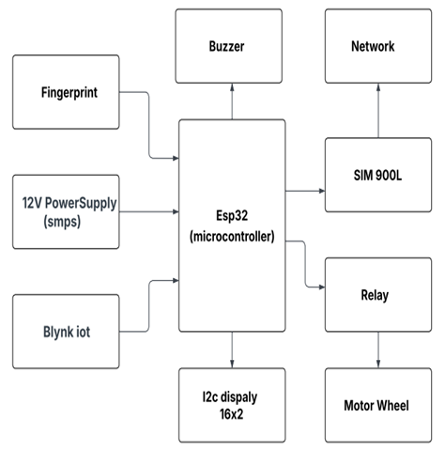
Fig 3.2.1 Block Diagram of Fingerprint Based Smart Vehicle System
The block diagram represents the architecture of the Fingerprint-Based Smart Vehicle Safety System, where the ESP32 microcontroller acts as the central unit controlling all modules. The fingerprint sensor sends user authentication data to the ESP32, which then decides whether to activate the relay and allow the motor wheel to run. The SIM900L GSM module connects to the network to send SMS/call alerts during unauthorized access, while the buzzer provides audible warnings. The I2C LCD display (16x2) shows system messages, and Blynk IoT enables remote monitoring. A 12V SMPS powers the system, ensuring stable operation of all connected components.
3.4.1 Working Flow
Normal Access Flow
- Vehicle power ON
- User places finger
- Valid print → unlock servo → enable relay → vehicle starts
Intruder Flow
- Unknown print detected
- Buzzer alarm ON
- GSM SMS + Call sent to owner
- Vehicle stays locked
3.5 Flowchart
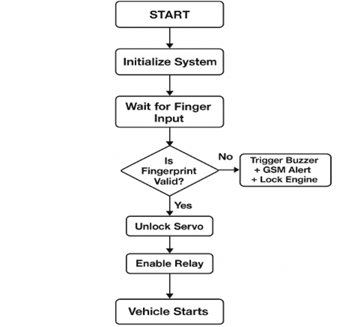
Fig 3.5.1 Flowchart of Fingerprint Based Smart Vehicle System
The flowchart shows the working process of the Fingerprint-Based Smart Vehicle Safety System. After powering on, the system initializes all components and waits for a fingerprint input. The fingerprint is then checked for validity—if it is unauthorized, the system triggers the buzzer, sends a GSM alert to the owner, and keeps the engine locked. If the fingerprint is valid, the servo motor unlocks the physical lock and the relay is activated. Finally, the vehicle engine starts, allowing only authorized users to operate it.
3.5.1 Algorithm
- Initialize UART, fingerprint sensor, GSM module
- Check stored fingerprints & load templates
- Monitor fingerprint scanner
- If match found:
  - Toggle servo lock
  - Toggle relay output
- Else:
  - Send SMS + call owner
  - Buzzer alarm
3.6 System Architecture Diagram
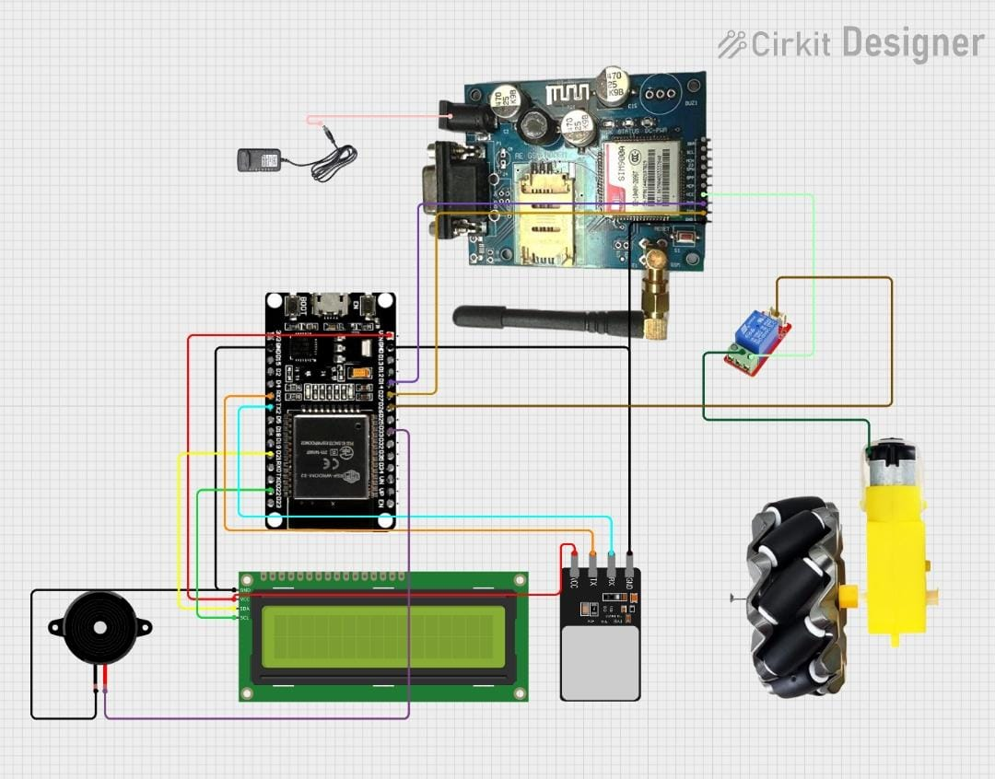
Fig 3.9.1 Circuit Diagram of Fingerprint Based Smart Vehicle System

3.6.1 Circuit Diagram Description
The circuit consists of five main sections:
- Biometric section
Fingerprint sensor interfaced with ESP32 UART
- GSM communication interface
SIM900 receives AT commands and triggers SMS+call
- Engine control unit
Relay controls DC motor power — simulating ignition
- Mechanical safety lock
Servo rotates to allow or block engine access
- User interface
Buzzer + LCD + IoT + mode switch
3.6.2 Advantages of Architecture
- Multi-layered security
The architecture combines biometric authentication, relay-based engine immobilization, servo mechanical locking, and buzzer alerts. This layered design ensures that even if one layer is bypassed, other protections remain active. It makes the vehicle extremely difficult to tamper with or start unlawfully.
- Real-time alert system
The GSM module instantly sends SMS and makes a call to the owner whenever an unauthorized fingerprint attempt is detected. This real-time response helps the owner take immediate action. It improves situational awareness and prevents unnoticed intrusions.
- Hybrid IoT + GSM communication
The system uses Wi-Fi-based IoT (Blynk) for remote monitoring and GSM for offline alerts. Even if internet connectivity is unavailable, GSM continues to send alerts. This hybrid model ensures continuous communication and high reliability.

- Biometric only access
Fingerprint authentication ensures that only registered users can start the vehicle. Since fingerprints are unique and cannot be cloned, the system eliminates risks from key duplication or remote hacking. This forms the strongest security layer.
- Cost-efficient system
The entire design uses inexpensive, readily available components like ESP32, GSM, and fingerprint modules. Despite providing smart security and IoT features, the system remains affordable compared to commercial vehicle security devices. This makes it suitable for large-scale implementation.

Chapter 4
RESULTS AND DISCUSSION
The Fingerprint-Based Smart Vehicle Safety System was tested under various real-time conditions to evaluate its accuracy, response time, and reliability. The results confirm that the system performs efficiently in authenticating users, preventing unauthorized access, and sending immediate security alerts through GSM and IoT platforms.
4.1 Experimental Setup
The experimental setup for the proposed system was carefully designed to simulate a real-world vehicle security environment. The core controller used was the ESP32 microcontroller, which interfaced with a fingerprint sensor for biometric authentication and a SIM900L GSM module for sending alert messages and calls. A relay module was connected to control a DC motor that represents the vehicle engine, ensuring that the engine could be enabled or disabled based on fingerprint verification. A servo motor was employed to demonstrate a mechanical locking mechanism, providing an additional layer of physical security. All components were interconnected using appropriate wiring to ensure reliable communication and control among the modules. Power management was handled using a dual-supply approach to maintain system stability and safety. A 12V SMPS was used to power the GSM module and the DC motor, as these components require higher current and voltage levels. A buck converter stepped down the 12V supply to a regulated 5V output for the ESP32, fingerprint sensor, and other low-power peripherals. The experiments were conducted in an indoor environment with stable mobile network coverage and active Wi-Fi connectivity to ensure reliable GSM alert transmission and IoT communication. This setup allowed thorough testing of authentication accuracy, alert responsiveness, and overall system reliability under controlled conditions.

4.2 Test Parameters & Observations
Table 4.2.1 Table of Test Parameters & Observations
Test Case | Observation | Result
System Power ON | All modules initialized correctly; LCD displayed status | ✔ Successful
Valid Fingerprint | Servo unlocked, relay activated, motor rotated | ✔ Successful
Invalid Fingerprint | Buzzer activated, SMS + call sent instantly | ✔ Successful
GSM Alert Test | SMS delivered within 3–5 seconds; call in 4 seconds | ✔ Successful
Engine Lock Test | Relay reliably cut off power | ✔ Successful
Power Failure | System auto-locked engine on restart | ✔ Successful
Mode Change | Fingerprint deletion/maintenance worked properly | ✔ Successful

The test parameters and observations summarized in Table 4.2.1 demonstrate the reliable performance of the proposed vehicle security system under various operating conditions. During the system power-on test, all hardware modules initialized correctly, and the LCD provided clear status messages, confirming proper startup behaviour. When a valid fingerprint was detected, the system successfully unlocked the servo mechanism, activated the relay, and allowed the DC motor to rotate, indicating correct engine authorization.
In the case of an invalid fingerprint, the system immediately triggered the buzzer and sent both an SMS and a phone call alert to the registered user, proving effective intrusion detection. The GSM alert test showed timely message delivery within 3–5 seconds and rapid call initiation, ensuring real-time notification. The engine lock test confirmed that the relay reliably cut off power during unauthorized access. Additionally, during power failure scenarios, the system safely returned to a locked state upon restart. The mode change test verified that fingerprint deletion and maintenance operations functioned accurately, highlighting the robustness and reliability of the overall system.

4.3 System Response Comparison
- Valid Fingerprint:
The system reacted instantly by unlocking the servo, enabling the relay, and starting the motor.
- Invalid Fingerprint:
The buzzer and GSM alerts were triggered immediately, while the engine remained locked.
- Unauthorized Attempt:
Alerts were communicated instantly to the owner through SMS and call.
- Engine Stop Scenario:
The relay cut off power smoothly, and the servo returned to locked mode.
This confirms the system’s robustness in both normal operation and intrusion scenarios.
4.4 Advantages Demonstrated
- Ensures complete biometric-based access control
- Provides instant emergency alerts even without internet
- Uses servo + relay for double-layer engine immobilization
- Responds fast with <1 sec biometric verification
- Highly reliable due to hybrid IoT + GSM communication
4.5 Sample Outputs
LCD Display Shows:
- “System Ready – Place Finger”: The LCD displays “System Ready – Place Finger” to indicate that the system has initialized successfully and is waiting for fingerprint input.
- “Access Granted – Engine ON”: When a valid fingerprint is detected, the LCD shows “Access Granted – Engine ON”, confirming successful authentication and engine activation.
- “Access Denied – Alerting Owner”: If an unauthorized fingerprint is scanned, the LCD displays “Access Denied – Alerting Owner”, indicating access rejection and alert initiation.
SMS Alert Example:
“ALERT! Unauthorized person attempting to access your vehicle.”
The SMS alert message “ALERT! Unauthorized person attempting to access your vehicle.” is sent to notify the vehicle owner immediately about a security breach.
• This SMS ensures remote awareness even when the owner is far from the vehicle.
• The serial monitors display fingerprint ID numbers to confirm successful or failed matches.
• GSM AT command responses are shown on the serial monitor to verify proper communication with the GSM module.
• System status logs on the serial monitor help in debugging and monitoring real-time system performance.
Serial Monitor:
Shows fingerprint match IDs, GSM AT responses, system status logs, etc.
4.6 Discussion
The experimental results clearly indicate that the proposed Fingerprint-Based Smart Vehicle Alert and Security System perform efficiently and reliably across all tested scenarios. The system demonstrated fast response times during fingerprint authentication, with accurate matching and minimal delay between user input and system action. Both authorized and unauthorized access cases were handled correctly, proving the robustness of the biometric verification process. The immediate triggering of alerts during invalid fingerprint attempts highlights the system’s effectiveness in preventing unauthorized vehicle usage and enhancing overall security.
The selection of the ESP32 microcontroller played a crucial role in the system’s performance. Its high processing capability and support for multiple communication interfaces enabled seamless integration of the fingerprint sensor, GSM module, relay, servo motor, and IoT features without conflicts or performance degradation. The ESP32 efficiently managed parallel tasks such as fingerprint matching, GSM communication, LCD updates, and actuator control, which is essential for real-time vehicle security applications. The stable operation observed during continuous testing confirms the suitability of ESP32 for advanced embedded security systems.
A key strength of the proposed system is the multi-layered security approach. The electronic locking mechanism using a relay ensures that the engine remains disabled unless valid authentication is detected, while the servo motor provides an additional mechanical lock that physically restricts vehicle operation. This combination significantly increases resistance against theft, as bypassing both electronic and mechanical locks is much more difficult than defeating a single security mechanism. The inclusion of a buzzer and LCD further enhances usability by providing immediate audible and visual feedback.
The GSM-based alert mechanism proved to be highly reliable, with SMS and call notifications being delivered within a few seconds of detecting unauthorized access. This ensures that the vehicle owner is informed instantly, allowing quick response even when the vehicle is unattended. The system’s ability to automatically lock the engine after power failure further adds to its safety and reliability, preventing misuse during unexpected shutdowns or restarts.
Overall, the results confirm that the proposed smart vehicle security system is practical, cost-effective, and suitable for real-world implementation. Its modular and scalable architecture allows future enhancements such as GPS tracking, AI-based threat detection, mobile application control, and cloud data logging. These upgrades can further improve security, monitoring, and user convenience, making the system a strong solution for modern smart vehicle protection.

Chapter 5
CONCLUSION AND FUTURE SCOPE
5.1 Conclusion
The Fingerprint-Based Smart Vehicle Alert & Security System successfully enhances automobile security by combining biometrics, GSM alerts, and electromechanical locking. The system verifies the user's identity using a fingerprint sensor, ensuring only authorized individuals can access the vehicle.
In the event of unauthorized attempts, the system locks the engine, triggers an alarm, and sends real-time alerts. This multi-layered defense structure makes conventional theft methods ineffective.
The system is:
- Cost-effective
- Fast and reliable
- Tamper-proof
- Expandable to commercial level
- Practical for real-world use in vehicles
This innovation contributes to the world of intelligent transport systems and smart automotive security.
5.2 Future Scope
1. Face + Finger Recognition (Dual AI Security)
Future versions of the system can integrate facial recognition along with fingerprint authentication to provide dual-layer AI-based security. This will make unauthorized access extremely difficult. Combining two biometrics increases accuracy and enhances protection against spoofing.
2. GPS Tracking (Live Map Location)
Adding a GPS module will allow real-time vehicle tracking through mobile applications or online dashboards. Users can monitor live location and movement in case of theft. It enhances safety by enabling quick recovery of stolen vehicles.

3. Mobile App Control (Lock/Unlock & Ignition)
A dedicated mobile app can allow users to remotely lock, unlock, and control the ignition system. This provides convenience and ensures security even when the user is far from the vehicle. It also allows monitoring system status through notifications.
4. Cloud Data Logging (Fingerprint Access History)
Storing fingerprint access logs on a cloud server will enable historical tracking of who accessed the vehicle and when. This is useful for multi-user vehicles, fleets, and rental services. It enhances transparency and improves overall security auditing.
5. AI Theft Pattern Learning (Automatic Threat Detection)
Artificial intelligence can be used to detect abnormal access attempts and identify suspicious behavioral patterns. The system can learn from past events and send early warnings before a theft occurs. This makes the system smarter and proactive.
6. Fuel Pump Cutoff System (Hard Immobilization)
Integrating a fuel pump cutoff will completely disable the ability of a thief to operate the engine. Even if mechanical locks are bypassed, cutting fuel flow ensures the vehicle cannot move. This provides a stronger level of immobilization for real vehicles.
7. Battery Backup & Solar Power (Reliable Power Supply)
Adding a rechargeable battery or small solar panel will keep the system active during power failures or battery disconnection. This ensures uninterrupted security and continuous monitoring. It also makes the system more sustainable and energy-efficient.
8. Voice Warning Speaker (Audible Security Alerts)
A loud voice-based warning system can be used to deter intruders by announcing security alerts and unauthorized access attempts. This makes the system more interactive and attention-drawing. It further enhances real-time threat response.

REFERENCE
[1] Abhay Gaidhani, Siddharth Pagare, Siddharth Pagare, Harshad Gaikwad, Jino Johnkurian “Biometric based smart antitheft bike protection system” International Journal of Scientific Research and Engineering Development-– Volume 7 Issue 3, ISSN: 2581-7175, May-June 2024
[2] P.S. Pilomina ,K.P. Harshavardhan, ShamilaM, V. Soma Laxmi and Muntadar Muhsen “Theft intimation of the vehicle over sms to owner who can stop the engine remotely” E3S Web of Conferences 564, 07012 (2024) ICPGRES-2024
[3] Prashant Kumar R.1, Sagar V. C.2, Santosh S.2, Siddharth Nambiar “Two-wheeler vehicle security system” International Journal of Engineering Sciences & Emerging Technologies, Dec. 2013. ISSN: 2231 – 6604 Volume 6, Issue 3, pp: 324-334 ©IJESET
[4] K.S. Tamilselvan, G. Murugesan and S. Sasikumar “Design and implementation of biometric based smart antitheft bike protection system” 978-1-5386-9432-9/18/$31.00 ©2018 IEEE
[5] SIMCom Wireless Solutions, “SIM900 AT Commands Manual”, SIMCom Documentation, 2020.
[6] Adafruit Industries, “Fingerprint Sensor User Guide”, 2022.
[7] Espressif Systems, "ESP32 Technical Reference Manual", 2023.
[8] Blynk IoT Platform Documentation — official website
[9] Arduino.cc — Library reference & ESP32 support files

